**STRESS TESTING OF CHAMELOEN WEBSITE**

**TABLE OF CONTENTS**

1-SUMMARY……………………………………………………………………………………..

2-INTRODUCTION……………………………………………………………………………..

3- TOOLS USED………………………………………………………………………………..

4-SCOPE OF TESTING………………………………………………………………………….

5-RESULTS…………………………………………………………………………………………

6-CONCLUSIONS……………………………………………………………………………….

7-REFERENCES……………………………………………………………………………………

**EXECUTIVE SUMMARY**

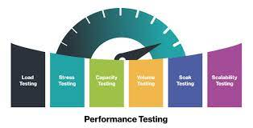  
Performance testing is a type of test that evaluates how well a website performs under various conditions to ensure optimal speed, responsiveness and stability. Below is a summary of the key steps in website performance testing.

Performance requirements:

Clearly define your site's performance requirements, including estimated response time, bandwidth, and resource usage. In order to assess a website's performance under heavy demand, stress testing entails creating severe scenarios. The main steps are summarised as follows. Specify your goals: Define the objectives and features of the website that will be put to the test under pressure. Determine Situations: Decide whether important scenarios—such as abrupt traffic spikes or huge transaction volumes—represent peak usage circumstances.

**INTRODUCTION**



Stress testing is a subset of performance testing used to assess an application's or system's resilience and stability in harsh environments. Stress testing is done to find the breaking point of the system, learn how it behaves under high load, and make sure it can withstand sudden increases in user activity without crashing or performing worse. Organisations can evaluate the scalability and dependability of their websites, infrastructure, and software with the aid of this type of testing.

Important details about stress testing consist of:

Severe Circumstances: Stress testing entails putting a system under circumstances that are outside of its typical functioning range. This might be caused by an abrupt spike in the number of users, many transactions, or other situations that strain the system to the breaking point.

A vital procedure for ensuring the best possible user experience on a website is performance testing, which evaluates the site's functionality in various scenarios. It entails assessing variables including responsiveness, speed, and stability to find possible bottlenecks and areas in need of development. Ensuring that the website can efficiently manage anticipated user loads, offer content fast, and react to user interactions swiftly is the aim. Speed and responsiveness are two important components of website performance testing: users want websites to load quickly and react to their activities swiftly. Performance testing gauges the speed at which web pages load, how long it takes to finish transactions, and how responsive the website is overall. Scalability: Performance evaluation assesses a website's ability to grow to accommodate more users.

.

**TOOLS USED**



**Apache JMeter:**

* Description: An open-source Java-based tool widely used for performance testing, including stress testing.
* Features:
* Support for various protocols (HTTP, HTTPS, JDBC, FTP, etc.).
* Distributed testing for scalability.
* User-friendly graphical interface.

**Gatling:**

* Description: An open-source, Scala-based tool designed for performance and stress testing.
* Features:
* High performance and efficiency.
* Scenario-based simulations.
* Real-time results and reports.

**LoadRunner (Micro Focus):**

* Description: A comprehensive performance testing tool that supports various application types, including web, mobile, and enterprise applications.
* Features:
* Virtual user simulation for realistic testing.
* Support for multiple protocols.
* In-depth analysis and reporting

**SCOPE OF TESTING**



A website's performance and stress testing might cover a wide range of topics in order to guarantee excellent functionality and dependability under diverse circumstances. The following are important domains that are included in website stress and performance testing:

Reaction Time:

* Time how long it takes the website to react to user requests during both low and high traffic periods.

Determine and fix any latency or delays that can affect the user experience.

Flow rate:

* Examine the website's ability to process a particular number of requests or transactions in a specified amount of time.
* Analyse how well the system handles and processes data flow.

Capacity of Concurrent Users:

* Find the highest number of concurrent users that the website can support without experiencing a noticeable drop in performance.

**RESULTS**

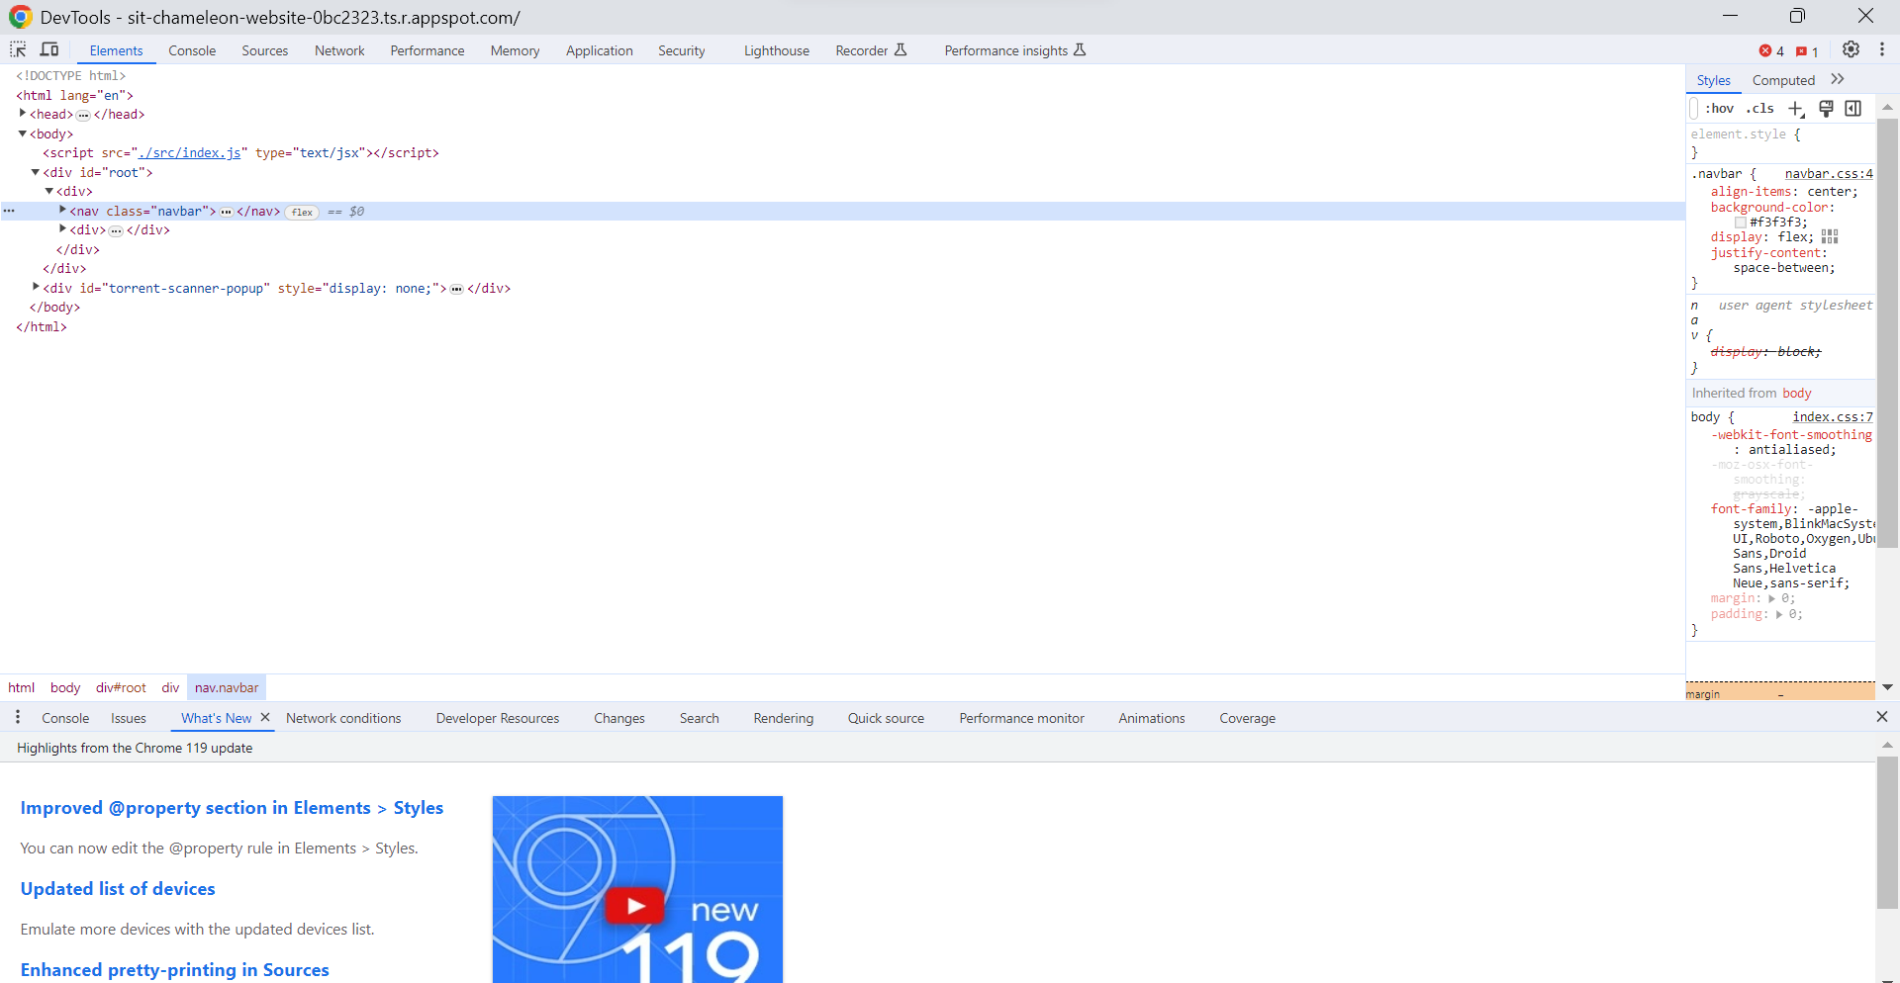

For the stress testing I open the website of the chameleon on the chrome and then went into the inspect option which is done by right clicking on. After that I went to the lighthouse options which is in the above menu bar as shown below in the screenshots.

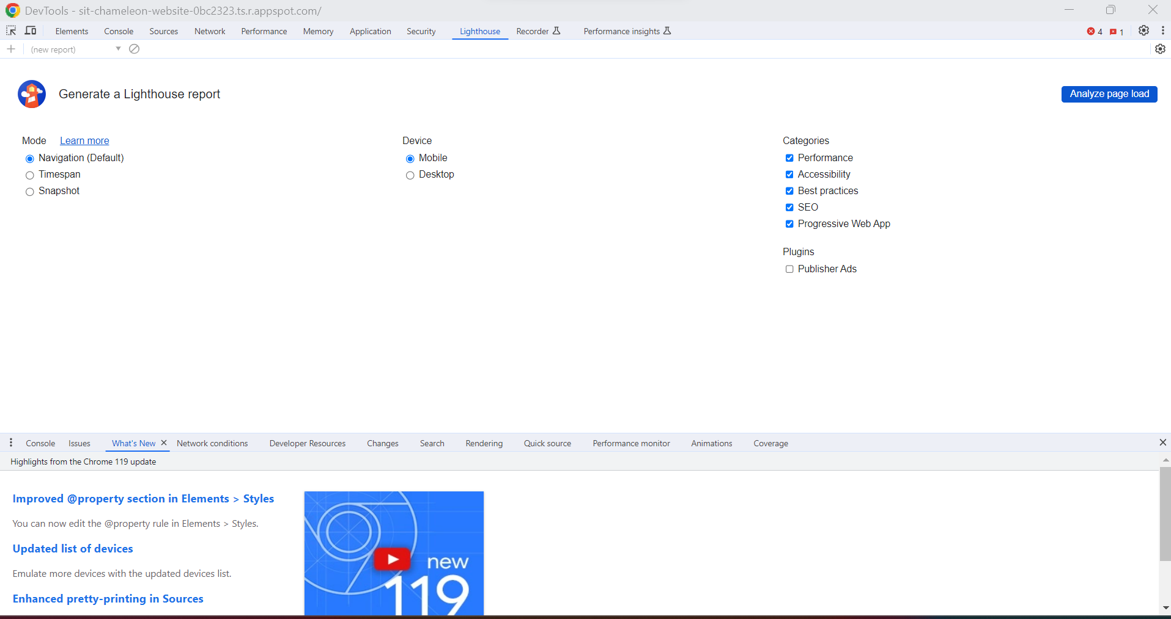

After that I clicked the analyse page load with the options available to me as the performance, accessibility, SEO and progressive web app it can be seen that the process is going on

The outcome can be seen from the below if we take the example of the performance testing it shows the score between the 0-49 and we can see many things from this such as the recommendations, below in the performance report we can see many errors are present such as the largest content , first contently paint etc . there are also the suggestions given for us to improve and analyse the website.

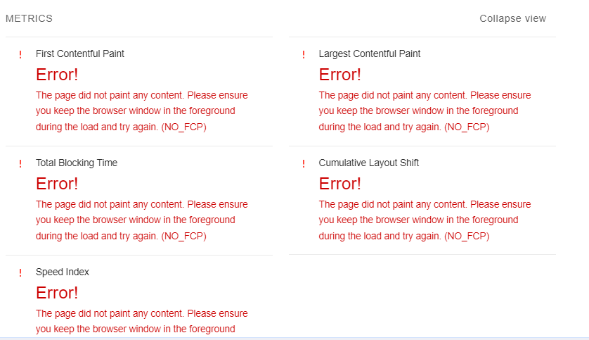

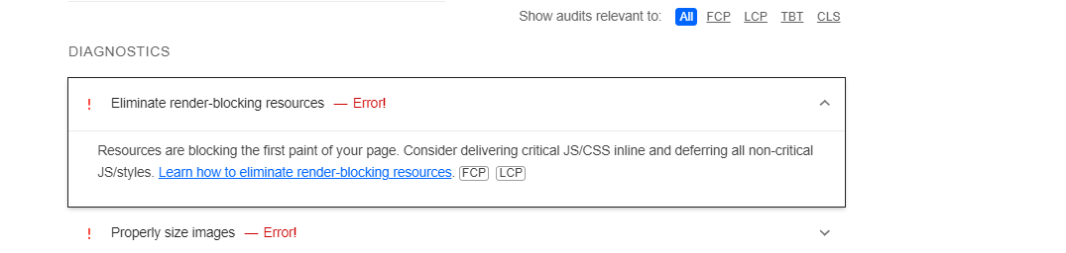

**CONCLUSION**



To sum up, performance and stress testing are essential to guaranteeing a website's best possible operation, dependability, and user experience. A thorough assessment of a website under various circumstances aids in locating possible weak points, bottlenecks, and places in need of development. Key lessons learned from stress and performance testing are as follows-Enhancing User Experience: By guaranteeing that the website reacts rapidly and effectively both during periods of low and high traffic, stress and performance testing are essential to enhancing user experience. Recognising bottlenecks-These tests assist in locating system bottlenecks that could affect the functionality of the website, such as sluggish response times, resource limitations, or concurrency problems. Providing Scalability-Organisations can better determine how well a website can handle rising user loads and data quantities by conducting scalability assessments.

REFERENCES

1- Miller, A. (n.d.). *Performance Testing, Load Testing & Stress Testing Explained*. [online] BMC Blogs. Available at: https://www.bmc.com/blogs/load-testing-performance-testing-and-stress-testing-explained/#:~:text=Stress%20testing%20is%20testing%20how [Accessed 9 Dec. 2023].

‌

2- Performance Testing vs. Load Testing vs. Stress Testing | BlazeMeter. (n.d.). *Performance Testing vs. Load Testing vs. Stress Testing | BlazeMeter*. [online] Available at: https://www.blazemeter.com/blog/performance-testing-vs-load-testing-vs-stress-testing.

‌

3- www.youtube.com. (n.d.). *How to do Website Performance Testing from EVERY ANGLE | Website Performance Analysis*. [online] Available at: https://youtu.be/ce6SCCqyL2c [Accessed 9 Dec. 2023].

‌